Tessella Project Number: 6870
Tessella plc 26 The Quadrant, Abingdon Science Park, Abingdon, Oxfordshire, OX14 3YS, UK
T: +44 (0)1235 555511 | F: +44 (0)1235 553301 | E: info@tessella.com | www.tessella.com

Client: STFC & ORNL
Mantid
PM report to Project Management Board
17th May 2011



Document Control
This document is under document control. All members of the distribution list will receive updated copies whenever alterations are made. All other copies are uncontrolled.

Contributors
Name | Role | Company
Nicholas Draper | Author | Tessella

Document Approval
Name | Role | Company

Distribution
Name | Role | Company
Project Management Board Members | Recipient | STFC
Mantid Project Repository | Filing | STFC

Revision History
Author | Issue | Date | Description
Nicholas Draper | V1.R1.M0 | 13-May-2011 | 1st version written

References
Document | Ref | Date | Details and Version
Short, Medium and long term requirements from ISIS Instrument groups | [SML REQ]] | 04-Aug-2009 | http://svn.mantidproject.org/mantid/trunk/Documents/Requirements/ShortMedLong%20Aug%2009.xls
Project Specification | [PS] |  | http://svn.mantidproject.org/mantid/trunk/Documents/Project%20Management/ProjectSpecification.doc
Stakeholder Plan | [SP] |  | http://svn.mantidproject.org/mantid/trunk/Documents/Project%20Management/StakeholderPlan.doc
Risk Register | [RR] |  | http://svn.mantidproject.org/mantid/trunk/Documents/Project%20Management/RiskRegister.xls

Table of Contents
1 Introduction 4
1.1 Purpose of this Document 4
1.2 Scope of this Document 4
1.3 Context of this Issue 4
2 Project Documentation 4
3 Project Status 4
3.1 Development Progress 4
3.2 Project Uptake 11
4 Supporting Mantid 15
4.1 Current Process 15
4.2 Training 15
4.3 Next 12 months 15
5 Financial review 15
6 Citing Mantid 15
6.1 Mantid DoI’s 15
7 Development Priorities 16
7.1 Priorities raised by the Scientific Steering Committee 16
8 Future Release Dates 16
9 Collaborating With Other Facilities 17
9.1 Interest from other institutions 17
9.2 Current Collaboration Strategy 18
9.3 Future Strategy 18

Introduction

Purpose of this Document
This report details the current state of the Mantid project and summarises the current plans for further development. The project management board will use the information in this report as a basis for the meeting.

Scope of this Document
The scope of this document is limited to the Mantid project, both for progress up to the meeting of the Project management board, and plans for the future.

Context of this Issue
This is the fifth project management report to the Mantid project management board and will provide input to the fifth meeting.

Project Documentation
The project documentation is available through the links below. The Risk Register has been reviewed and updated, however the other documents have not been changed since the last PMB meeting.
- Project Specification:
http://svn.mantidproject.org/mantid/trunk/Documents/Project%20Management/ProjectSpecification.doc
- Stakeholder Plan:
http://svn.mantidproject.org/mantid/trunk/Documents/Project%20Management/StakeholderPlan.doc
- Risk Register:
http://svn.mantidproject.org/mantid/trunk/Documents/Project%20Management/RiskRegister.xls

Project Status

Development Progress
Since the last PMB meeting in December 2010 we have completed three development iterations and released new versions of Mantid on the following dates:
- 20th December 2010
- 18th February 2011
- 6th May 2011
The rate of development within Mantid continued to increase in these releases compared to those beforehand, this is backed up by the project metrics in section 3.1.6. In particular we have made significant improvements to (among many others):
- Several usability improvements
  - The ease of installation has greatly improved on Windows and Mac OSX, and building from source
  - Manage directories Dialog
  - Data loading has been simplified using the Load Algorithm
- A redesign of the instrument display, including:
  - Uwrapping of the instrument on cylinders or spheres
  - Greatly improved picking options
- Initial Monte Carlo absorption correction has been implemented, but this has yet to be used in production
- Many improvement to our specific user interfaces, adding many new features and support for new instruments such as EQ-SANS
- Support for event has continued to improve with better memory management, persistence and improved algorithm support
- Python scripting continues to develop with more aspects of Mantid being exposed for control via python
- Multi dimensional model fitting had been implemented in our optimisation library, this supports fitting both shared and individual functions across multiple data sets.

Current Development team
ISIS | SNS
Nicholas Draper (Tessella, PM) | Stuart Campbell (SNS)
Martyn Gigg (Tessella) | Peter Peterson (SNS)
Roman Tolchenov (Tessella) | Russell Taylor (Tessella, Project Lead)
Owen Arnold (Tessella) | Janik Zikovsky (SNS)
Steve Williams (STFC) | Mathieu Doucet (SNS)
Michael Whitty (STFC) | Michael Reuter (SNS)
Anders Markvardsen (70%, STFC) | Andre Savici (SNS)
Alex Buts (50%, STFC) | Vickie Lynch (SNS)
Ronald Fowler (50% eScience) | Dennis/Ruth Mikkleson (SNS, Part time)
 | Wenduo Zhuo (SNS)
 | Shelly Ren (SNS)
Since the last PMB meeting, the ISIS team has shrunk by one member as Sofia Antony left, and the SNS team has increased by two adding Wenduo Zhuo and Shelly Ren. In 4 weeks Michael Whitty will finish his sandwich studentship, although he will be replaced by two students, one starting in 6 weeks and another in September.
The development team is working well together. We continue to encourage the knowledge sharing approach we have used up until know though the following mechanisms:
- Monthly developer meetings
These are now held once per iteration, ad-hoc meetings are held in between as required
- Pairing inexperienced developers with mentors when working in ‘new’ areas
- Mantid developer workshops
We have introduced daily “stand up” meetings between the developers; to keep the whole team informed what everyone else is doing, and what problems they are encountering. This allows other developers to offer advice, warnings or assistance. Traditional “stand up” meetings would clearly not work with a team of this size across two sites, it would take up far too much time from the team. By holding the “stand up” meetings using instant messaging via skype it takes very little time from the team, while delivering the same benefits. It also makes it easy to spin off more specific focussed groups to discuss issues in more detail. This approach has definitely increased the communication and understanding between developers across the two facilities.

Contributing Scientists
There are several scientists that also actively contribute to the Mantid project. While there contributions are on a part time basis, often they contribute some of the best ideas.
Contributor | Contribution | Contributor | Contribution
Laurent Chapon | C++ algorithms, scripts | Jason Hodges | Python algorithms
Pascal Manuel | C++ algorithms, scripts | Garrett Grantroth | Scripts, debugging support
Aziz Daoud-Aladine | Scripts, debugging support
Rob Dalgleish | Reflectometry UI, Python algorithms, scripts
Tim Charlton | Python algorithms, scripts
Max Skoda | Reflectometry UI, Python algorithms, scripts
Richard Heenan | Scripts, debugging support
Stephen King | Scripts
Jon Taylor | Python Algorithms, scripts, debugging support
Stephen Cotrell | Muon C++ models, scripts
Timmy Ramirez-Cuesta | Scripts
Franz Dremmel | Scripts, debugging support
Spencer Howells | Scripts, Python Algorithms, debugging support
Several scientists have also either written or contributed to the development of instrument definitions, these include;
- Joe Kelleher
- Stephen Cottrell
- Francis Pratt
- Timothy Charlton
- Maximilian Skoda
- Matt Tucker
- Rob Dalgliesh
- Pascal Manuel.

Development Organisation
Currently the Mantid effort has been largely split into two teams, a core Mantid team, and a sub team concentrating on the VATES subproject. The current iteration will see the merging of the building approaches between Mantid and VATES, together with the first release of a prototype of the visualization for a group of instrument scientists. With feedback on the prototype it is possible that different members of the team may get involved in aspects of VATES.
SNS Mantid
VATES
ISIS
Mantid
Owen Arnold
Alex Buts
Ron Fowler
Peter Peterson
Stuart Campbell
Russell Taylor
Matthieu Doucet
Alex Buts
Ron Fowler
Michael Reuter
Janik Zikovsky
Andre Savici
Vickie Lynch
Martyn Gigg
Steve Williams
Michael Whitty
Anders Markvardsen
Nick Draper
Roman Tolchenov

We have made several improvements to the support tools we are using to better support a distributed team:
- CMake – We have moved our build system to Cmake providing a more flexible and more simple build interface for what is a complex project to build for multiple environments.
- Jenkins – Our previous continuous integration server environment was somewhat cobbled together, leading to maintenance issues and limited functionality. Jenkins gives us a full featured environment that is easier to maintain.
- CPack – Building good installers is always more work than you would anticipate. CPack has allowed us to support building the Mac installer and the Red Hat RPM from the same code base. CPack is also able to build installers for other Linux variations and potentially windows in the future, providing more functionality and potentially further simplification.
There remain a few problems with the support tools we have that we have still to resolve. Some of the tools we use are housed at ISIS, and can perform less well for remote facilities. This is complicated further as the reliability of the server that houses them has been rather poor over the last two months. Equally we need to consider to future possibility on a lengthy unexpected network outage at any one facility.
- Version Control system – We currently use Subversion, but it does not support the use of replicated repositories. We plan on moving to a distributed version control system to allow local hubs, possibly with an external master instance.
- Bug tacking system – The TRAC system is important both for allocating and tracking the development work for an iteration, but during the testing period is essential to allow the distributed team to work as one. There is not however an obvious alternative at this point.
- Wiki – Currently our Mantid help system relies on our wiki being available. There is a need for an offline help system, and this has also been raised by the US scientific steering committee. We plan on using a static version of our help pages served via the QT assistant. This will allow the wiki to remain the master source of the information, and we can scrape the information into a static copy for each release.

Future development structure
As the project matures it is worth discussing what the best project structure might be, particularly if the project were to expand to other facilities in the future. I present a comparison of two options here as a starting point for discussion.

Comprehensive local support
This is the current organisation of the project, were each facility provides staff to the project to cover all of the scientific areas supported by that facility. This approach ensures there will be knowledgeable local support available at each facility. Larger projects require coordination between the teams supporting that particular scientific area. This structure increases the risk of divergent approaches between facilities. This has already occurred within Mantid with the SANS interfaces, and there is a risk of a similar situation developing with single crystal analysis.

Centres of Excellence
This would involve specific areas building larger collocated teams to provide a higher level of knowledge and support of particular scientific areas. This would make larger development easier due to collocation of a significant team knowledgeable in the scientific area with world leading scientists. This would not remove the need for local support for each scientific area, but would perhaps reduce to amount of staff required overall. This approach would have significant potential drawbacks: it increases the reliance on other facilities, selection of centres of excellence would be highly controversial, and the centres of excellence may not match the skills and knowledge of the current team members.

Testing

Automated Testing
The Mantid framework has an extensive test suite of 3,119 automated tests which are run on every code submission by all of the build servers (Windows 32, Windows 64, RHE 5 and 6, Mac OSX). Any failures are immediately emailed to all of the development team ensuring rapid feedback for any side effects their changes might have made. This provides good coverage of the framework itself.
The System Test suite tests user’s scripts and warns the development team if any change will affect the end results of common scripts.
The current system tests cover:
- Powder Diffraction (GEM & WISH)
- Direct & Indirect Inelastic Convert To Energy
- Polref data reduction
- Data Loading Raw Vs Nexus
- SANS: Analysis, Centre Finding, File summation, Batch Operation, Single Period No Trans
- EQ-SANS
- HFIR Reduction
We have made some progress in improving the SNS and HFIR based system tests, however there is more to do.

Performance Testing
It has become apparent that there is a need for frequent automated performance testing to feedback areas were performance of functionality has changed in a timely manner so it can be linked to the underlying cause of the change. The lack of this form of support has caused difficulties for instrument scientist in the past, when small changes to performance, that had been discounted by the development team, caused much greater problems when applied to large data volumes.
We have introduced an automated performance testing framework, where test are defined in a similar way to the unit tests we currently have. This records the performance history of the tests in a database, for comparison against previous timings.
At present the number of tests is very small and clearly needs to be improved for this to be of any real benefit. We also need to develop some automated reporting tools to highlight changes in performance to the development team. Associated with this work we will need to build a dedicated performance testing server, so other tasks do not alter the timings of the performance tests.

Manual Testing
The manual testing approach continues to be a very efficient compromise between quality and time taken, as well as improving communication and understanding within the team. The entire development team is involved in the testing of each release, each testing the tickets of others. The testing period for releases has been 3 days, which as a proportion of the overall iteration time is rather small (≈7%), the most recent release had a longer testing overall period, but this still equated to 3 man days per developer.
It is worth mentioning that our most productive testers Michael Whitty is a sandwich student and will be leaving before the next release. In the last release he tested ¼ of the tickets. While we will be replacing him it is unlikely that his replacement will match his productivity. This will have to be considered in testing future releases.

Project Metrics
SubProject | Files | Statements | %comments
Mantid Framework | 1,897 (1,396) | 247,406 (153,950) | 18.8 (21.8)
MantidPlot | 545 (497) | 94,268 (89,685) | 12.9 (12.8)
VATES | 92 | 4,936 | 19.2
Total | 2,534 (1,893) | 346,610 (243,635)
The metrics are defined as follows:
Metric | Description
Files | The number of .h, .cpp, .xml and .py files (not including third party libraries) included in the analysis.
Statements | The number of valid C++ statements, loops, conditional statements and pre processor directives are included.
% Comments | This the percentage of the overall number of lines which are comment lines. I have not directly reported the number of lines in the file, but a good rule of thumb is that it is roughly twice the number of statements.
The Mantid Framework code has consistently grown since the last PMB (the previous values are in brackets), as would be expected with the addition of the new functionality described in section 3.1. The rate of increase to the MantidPlot code has once again picked up as we have added further visualization functionality. This is also the first time I have listed the VATES code, it should be noted that this in only one aspect of the VATES project, much of the rest of the code is reported under the Mantid Framework code.

Ticket completion rate
Development on Mantid is performed in two month iterations, each of which ends with an official release of the software. Longer pieces of work sometimes have to span a development iteration in which case that piece of work appears as completed only in the iterations when it becomes available to the users.
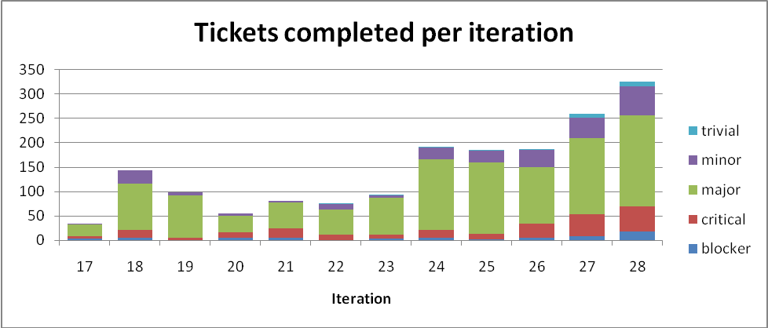

I have restricted the data to the last 12 iterations, with Iteration 26, 27 and 28 being new since the last meeting of the PMB. The completion rate continues well, with the recent large increases in tickets being completed are partially due to increased productivity of the team, but I believe there is also an effect on the numbers due to the tickets being finer grained.

Project Uptake

Mailing List Subscriptions
Our software download site no longer requires people to register to a mailing list in order to download the installer packages. A simple analysis of the email domains shows that while the majority of the users are from ISIS, followed by ORNL and we have had some interest from other institutions and universities.
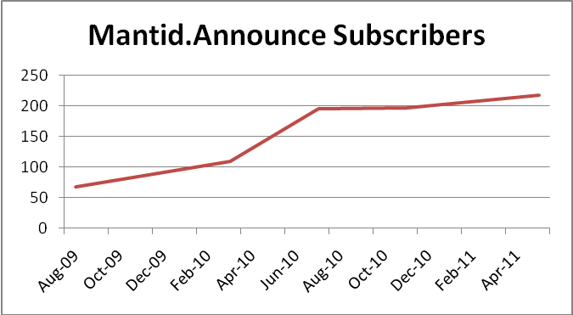
Summary
Date | Users
Aug-09 | 68
Mar-10 | 109
Jul-10 | 195
Nov-10 | 197
May-11 | 217

Current domain breakdown
Domain | 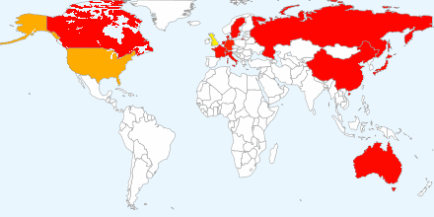  count
stfc.ac.uk | 75
ornl.gov | 28
gmail.com | 19
ill.fr | 3
swansea.ac.uk | 2
caltech.edu | 2
esss.se | 2
lanl.gov | 2
tudelft.nl | 2
chem.ox.ac.uk | 2
risoe.dtu.dk | 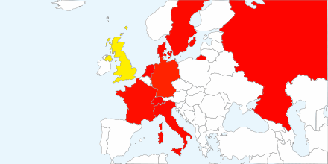  2
isc.cnr.it | 2
anl.gov | 2
bath.ac.uk | 2
yahoo.com | 2
uwstout.edu | 2
ansto.gov.au | 2
hmi.de | 2
j-parc.jp | 2
owlpic.com | 2

domain | count
shef.ac.uk | 1
sheffield.ac.uk | 1
sms.ed.ac.uk | 1
rediffmail.com | 1
imperial.ac.uk | 1
fysik.uu.se | 1
nf.jinr.ru | 1
live.com | 1
esrf.fr | 1
thorsbro.dk | 1
fi.isc.cnr.it | 1
usyd.edu.au | 1
dur.ac.uk | 1
ciarlette.com | 1
aber.ac.uk | 1
msn.com | 1
tempinbox.com | 1
cea.fr | 1
126.com | 1
bristol.ac.uk | 1
physics.org | 1
chem.gla.ac.uk | 1
bellsouth.net | 1
uea.ac.uk | 1
ill.eu | 1
hotmail.com | 1
sdstate.edu | 1
fz-juelich.de | 1
qmul.ac.uk | 1
mailinator.com | 1
psi.ch | 1
ed.ac.uk | 1
googlemail.com | 1
maxlab.lu.se | 1
paxam.co.uk | 1
mcs.anl.gov | 1
warwick.ac.uk | 1
jaea.go.jp | 1
liverpool.ac.uk | 1
space-research.org | 1
mails.gucas.ac.cn | 1
mta.ca | 1
physics.ox.ac.uk | 1
lboro.ac.uk | 1
ph.tum.de | 1
rri.kyoto-u.ac.jp | 1
ihep.ac.cn | 1
ati.ac.at | 1
talktalk.net | 1
surrey.ac.uk | 1
yahoo.co.uk | 1

Software Downloads
Since December 2010 when we removed the requirement to subscribe to the mailing list, we began to track downloads. We record the ip-address along with the file downloaded, due to the nature of facility users sharing ip-addresses it is not possible to only report on unique ip-addresses, but the total count of downloads shows some interesting trends. I should also stress that this does not currently include Unix RPM downloads via the ISIS or SNS Red Hat repositories.
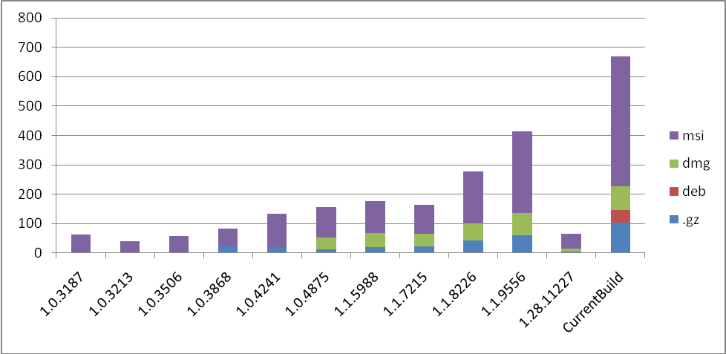
- Despite monitoring occuring only since december some very old versions of Mantid have been downloaded many times.
- The number of downloads is much higher than I was expecting, but I would not expect multiple downloads to the the sole explanation of this.
- Not everyone immediately jumps to download a new version although 66 downloads in 5 working days is quite good.
- Many more people download the packaged source code than I was expecting. Some of this may be due to “robots” trawling the site, but I would expect that to have a linear baseline effect across

Instrument usage

ISIS
In Use (14) | Under Evaluation (8) | Under Development (1)
Hrpd | Engin-X | Vesuvio
Gem | Surf
Mari | Crisp
Merlin | Osiris
Maps | Iris
Loq | Polaris
Tosca | Inter
Hifi | Polref
Musr
Emu
Wish
Offspec
Sans2d
Let

SNS
In Use (3) | Under Evaluation (2) | Under Development (6)
SEQUIOA | ARCS | EQ-SANS
POWGEN | NOMAD | BASIS
CNCS |  | SNAP
 |  | VISION
 |  | HYSPEC
 |  | TOPAZ

HFIR
In Use (0) | Under Evaluation (2) | Under Development (0)
 | GP-SANS
 | BIO-SANS

Others
In Use (0) | Under Evaluation (1) | Under Development (0)
 | EXED (HMI)

Supporting Mantid

Current Process
The current support procedures have not changed, although we have increased the number of people that monitor our support requests. The email address mantid-help@mantidproject.org is now monitored by:
- Nick Draper
- Russell Taylor
- Stuart Campbell
- Peter Peterson
- Martyn Gigg
- Matheiu Doucet

Training
We have not held any further sessions of our Python or Mantid scripting training courses since the last PMB meeting.

Next 12 months
We have started to receive support requests and improvement suggestions direct from users of Mantid at their home institutions after visiting one of our facilities. The volume of these is still low, so we are treating them in the same way as any other requests. However if these were to grow significantly we would need to consider to what level we should support them and how best to do it.

Financial review
Details of the project financial state is included in Appendix A and B. For ISIS the recent renewal is currently estimated to last until December 2012.
The initial order for Russell Taylor at ORNL is currently estimated to end at the start of August 2011.

Citing Mantid
It has been agreed in the Mantid memorandum of understanding that we will define a method for citing the usage of Mantid in scientific papers. We had decided to follow the approach of using DOI’s to identify and cite the software. This has been slightly controversial with the British Library, but after exchanging a few emails it appears that an agreement can be reached.
- DoI’s are specific to an individual release, and would need to be applied as part of the release process.
- We would have to provide an indefinitely supported landing page for the DoI, specifying the details of the release (authors etc).
- We can have multiple DoI’s for different subsections, but this will multiply the number of DoI’s Mantid accumulates. At present with 6 releases per year with the two DoIs listed below we would accumulate 12 DoI’s per year.

Mantid DoI’s
Mantid needs to support both a main DoI for the body of the framework, which will have a lot of contributors, it is however possible in the Landing page to classify the contributors based on their role within that release. VATES is a significant sub project, and probably warrants a separate DoI, especially as the current plan is to provide this as a separate installation package. I suggest the following initial separation as a starting point for discussion.
Mantid Framework
Owners: Nick Draper, [Entire development Team], [Contributing Scientists], [PMB Board members]
VATES
Owners: Nick Draper, [VATES development Team], [Contributing Scientists], [PMB Board members], Toby Perring

Development Priorities

Priorities raised by the Scientific Steering Committee
- Further improvements to the instrument display
  - Colour map adjustment via the mouse
  - Improvements for manual peak picking
  - Allowing drawing of manual masks
- Red Hat 6 specific bugs e.g. graph symbol crash
- Offline Help Pages
- Plotting and rebining curvilinear data correctly
- Direct Inelastic improvements
  - Maintaining data in events for longer through the workflow
  - Splitting the data into chunks to improve performance on low spec laptops
- A longer term ongoing effort to improve the interaction between Python and Mantid, to create a more flexible and powerful interface
We also discussed the need to discuss and track longer term priorities (greater than one iteration), and we agreed that this would be a useful focus for the Joint Scientific Steering Committee meetings.

Future Release Dates
The planned release dates for the rest of the year are:
- 1st July December 2011
- 23rd September 2011
- 18th November 2011

Collaborating With Other Facilities

Interest from other institutions

Reactor Sources

ILL
Emmanuel Farhi visited Mantid at ISIS in April to further investigate Mantid with a view to increasing usage at the ILL. Andrew Harrison, Mark Johnson and Emmanuel are very keen to adopt Mantid throughout but accept that to be successful at the ILL they need to win the hearts of the Instrument scientists. As such we discussed an approach to develop a pilot in one area (triple axis) to show the capabilities of Mantid to a wider audience. At present they have no funding available for this work, and Emmanuel himself will not have any time to move this on significantly. Apparently funding should become available around October.
If this does go ahead there are obvious synergies between some of this work and direct applications to the Triple Axis spectrometers at HFIR. I would ensure that Andre was involved in some of this work to ensure its applicability across facilities.

Julich and HDRI
We had a visit from the German labs in Julich and Garching to learn more about Mantid, and the Mantid collaboration. They were looking for two reasons, the first is as part of the HDRI project they have some money to do a pilot project to support GISANS data analysis, they are looking for a framework to base future developments on. The second is the more strategic reason that we have seen at ISI and the SNS, a drive to have a consistent software platform across the various instruments at Julich and possibly the reactor sites in Germany.

They are interested in the Mantid project and in particular the VATES project as some of the instruments already use Horace, and others could benefit from the same multidimensional fitting. We discussed two potential ways of working as their needs clearly split into a pilot scheme and a larger strategic decision.
- For a pilot we could mentor a member of their staff within the ISIS offices (assuming they cover expenses) for a few weeks while they get up to speed. Then we would be able to help remotely for the pilot.
- If they wanted “A seat at the top table”, as in equal partnership with ISIS and ORNL, then I explained that they would have to agree to the same terms as ISIS and ORNL have, most notably that they would provide resources commensurate with the use of Mantid.

They are also looking at other possibilities, although it may only be one. Apparently Vitess has a rarely used ability to add analysis steps into loaded data. They are looking at extending this as a possible approach to perform their data analysis, making use of the data structures and plotting in Vitess. However they did acknowledge that Vitess is nowhere near as developed as Mantid and it is only supported by one person at the HMI, so it would be continuing the single point of failure approach.

Pulsed Neutron sources

J-Parc
We had decided to try and agree on a single intermediate data format across the three institutions, ISIS, SNS and J-PARC. ISIS and SNS jointly wrote a proposal and delivered it to Toshiya Otomo. Recent developments at J-Parc have no doubt altered their priorities. The document remains a useful design for use within the Mantid project.

ESS
Stig Skelboe the Head of the Data Management Centre of the ESS is visited Mantid at ISIS on the 14-15th of December.
“We think that there is basis for future cooperation of mutual benefit. We have reported our views to Dimitri and Ken and after Christmas we are going to discuss how to proceed.”
There first interest is in improving the integration between McStas and Mantid. Although longer term their main aim would be in extending Mantid to correctly handle all the corrections for multiple rep rate experiments.

Chinese SNS
We have heard nothing further from the C-SNS since the last PMB.

Others

DANSE
The DANSE team visited both ISIS and the SNS to discuss the various products and libraries they have produced. The Mantid team at both facilities agreed that there are certain areas where some level of integration with the DANSE software makes perfect sense. One of the most promising areas is SANS, and the SANSView application. This may provide a suitable platform to integrate Richard Heenan’s FISH models into, saving the effort of rewriting the application. However in doing so we would have to accept some of the ongoing support for that application. It is however true that if we were to write something ourselves we would then also have to maintain it into the future.

VISIT
In April we had a short visit from two VISIT developers to the Mantid team at ISIS. This had been arranged before the change to Paraview, but after discussion with the developers we agreed to continue with the visit.
We talked with Hank Childs (from Lawrence Berkeley National Lab) and Jeremy (from ORNL), discussed what we are doing, where we are aiming, and covered the issues we had encountered with implementing VISIT. Working together we investigated some of the issues, and possible other approaches to solving the same issues.
There remained several issues that would prevent immediate re-adoption of VISIT. We did discuss the possibility of re-adopting Visit in a second release of the VATES code. The Visit developers were confident that the issues could be overcome and that these changes would not conflict with their existing user base. However it was also clear that they would be looking for some funding to make these changes. Hank was clearly suggesting the Jeremy was the ideal person both in skills, location and desire to make these improvements, but that they would need to be given some funding to do them.
This is an option we need to consider if it aligns with the strategic goals of our project.

Current Collaboration Strategy
The current strategy that has been approved in previous meetings of the PMB is:
- We will not explicitly encourage other institutions to adopt Mantid, but we will respond to facilities that contact us.
- In order that they may properly evaluate Mantid, we will provide assistance to create a loading routine for one format of their data, and one instrument definition.
- We explain for anyone to join the collaboration as an equal partner it would need to be agreed by the PMB, and they would need to sign a similar Memorandum of Understanding that exists between ISIS and ORNL.
- Smaller collaborations are possible, but those developments would not benefit from significant amounts of time from the development team, and would not get representation at the PMB.

Future Strategy
With several facilities showing interest in Mantid it is worth revisiting the current strategy to ensure we agree on a common approach for the future.

